**Log in to Azure**

Sign in to the Azure portal at [https://portal.azure.com](https://portal.azure.com/) with your Azure account.

**Create a function app**

You must have a function app to host the execution of your functions. A function app lets you group functions as a logic unit for easier management, deployment, and sharing of resources.

1. Select the **New** button found on the upper left-hand corner of the Azure portal, then select **Compute** > **Function App**.

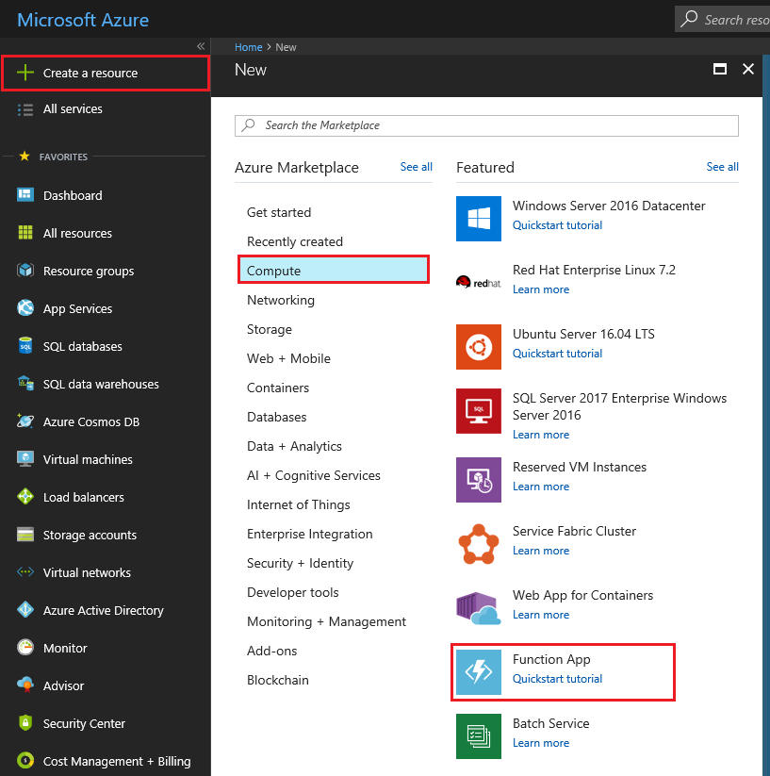

1. Use the function app settings as specified in the table below the image.

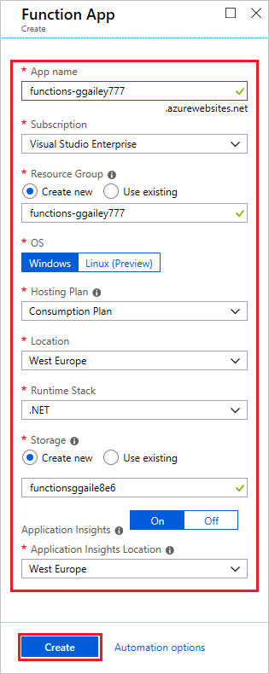

| **Setting** | **Suggested value** | **Description** |
| --- | --- | --- |
| **App name** | Globally unique name | Name that identifies your new function app. Valid characters are a-z, 0-9, and -. |
| **Subscription** | Your subscription | The subscription under which this new function app is created. |
| [**Resource Group**](https://docs.microsoft.com/en-us/azure/azure-resource-manager/resource-group-overview) | myResourceGroup | Name for the new resource group in which to create your function app. |
| **OS** | Windows | Serverless hosting is currently only available when running on Windows. For Linux hosting, see [Create your first function running on Linux using the Azure CLI](https://docs.microsoft.com/en-us/azure/azure-functions/functions-create-first-azure-function-azure-cli-linux). |
| [**Hosting plan**](https://docs.microsoft.com/en-us/azure/azure-functions/functions-scale) | Consumption plan | Hosting plan that defines how resources are allocated to your function app. In the default **Consumption Plan**, resources are added dynamically as required by your functions. In this [serverless](https://azure.microsoft.com/overview/serverless-computing/) hosting, you only pay for the time your functions run. When you run in an App Service plan, you must manage the [scaling of your function app](https://docs.microsoft.com/en-us/azure/azure-functions/functions-scale). |
| **Location** | West Europe | Choose a [region](https://azure.microsoft.com/regions/) near you or near other services your functions access. |
| **Runtime stack** | Preferred language | Choose a runtime that supports your favorite function programming language. Choose **.NET** for C# and F# functions. |
| [**Storage**](https://docs.microsoft.com/en-us/azure/storage/common/storage-quickstart-create-account) | Globally unique name | Create a storage account used by your function app. Storage account names must be between 3 and 24 characters in length and may contain numbers and lowercase letters only. You can also use an existing account, which must meets the [storage account requirements](https://docs.microsoft.com/en-us/azure/azure-functions/functions-scale#storage-account-requirements). |
| [**Application Insights**](https://docs.microsoft.com/en-us/azure/azure-functions/functions-monitoring) | Default | Application Insights is enabled by default. Choose a location near your function app. |

1. Select **Create** to provision and deploy the function app.
2. Select the Notification icon in the upper-right corner of the portal and watch for the **Deployment succeeded** message.

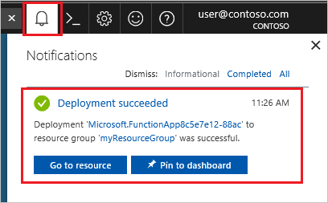

1. Select **Go to resource** to view your new function app.

**Tip**

Having trouble finding your function apps in the portal, try [**adding Function Apps to your favorites in the Azure portal**](https://docs.microsoft.com/en-us/azure/azure-functions/functions-how-to-use-azure-function-app-settings#favorite).

Next, you create a function in the new function app.

**Create an HTTP triggered function**

1. Expand your new function app, then select the **+** button next to **Functions**, choose **In-portal**, and select **Continue**.
2. Choose **WebHook + API** and then select **Create**.

A function is created using a language-specific template for an HTTP triggered function.

Now, you can run the new function by sending an HTTP request.

**Test the function**

1. In your new function, click **</> Get function URL** at the top right, select **default (Function key)**, and then click **Copy**.
2. Paste the function URL into your browser's address bar. Add the query string value &name=<yourname> to the end of this URL and press the Enter key on your keyboard to execute the request. You should see the response returned by the function displayed in the browser.

The following example shows the response in the browser:

The request URL includes a key that is required, by default, to access your function over HTTP.

1. When your function runs, trace information is written to the logs. To see the trace output from the previous execution, return to your function in the portal and click the arrow at the bottom of the screen to expand the **Logs**.

**Clean up resources**

Other quick starts in this collection build upon this quick start. If you plan to work with subsequent quick starts, tutorials, or with any of the services you have created in this quick start, do not clean up the resources.

*Resources* in Azure refers to function apps, functions, storage accounts, and so forth. They are grouped into *resource groups*, and you can delete everything in a group by deleting the group.

You created resources to complete these quickstarts. You may be billed for these resources, depending on your [account status](https://azure.microsoft.com/account/) and [service pricing](https://azure.microsoft.com/pricing/). If you don't need the resources anymore, here's how to delete them:

1. In the Azure portal, go to the **Resource group** page.

To get to that page from the function app page, select the **Overview** tab and then select the link under **Resource group**.

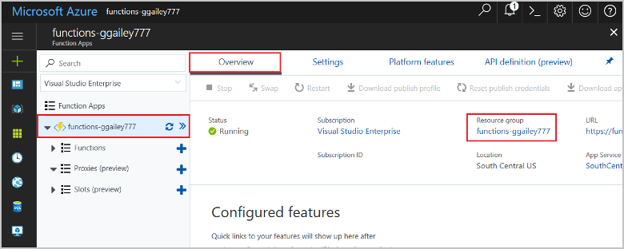

To get to that page from the dashboard, select **Resource groups**, and then select the resource group that you used for this quickstart.

1. In the **Resource group** page, review the list of included resources, and verify that they are the ones you want to delete.
2. Select **Delete resource group**, and follow the instructions.

Deletion may take a couple of minutes. When it's done, a notification appears for a few seconds. You can also select the bell icon at the top of the page to view the notification